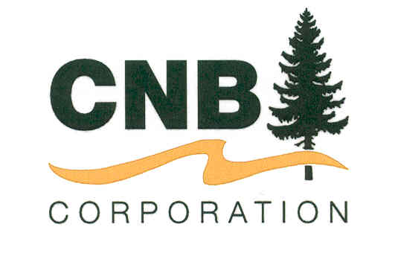

January 19, 2021, Cheboygan MI – CNB Corporation Declares Dividend

CNB Corporation President & CEO Matthew E. Keene announced that at its regular meeting held January 14, 2021 the board of directors declared a $0.40 per share regular dividend and a special dividend of $0.10 per share payable to shareholders of record January 29, 2021. The dividend has a pay date of February 12, 2021.

CNB Corporation is the holding company which owns 100% of Citizens National Bank of Cheboygan, a full-service community bank headquartered in Cheboygan with offices in Onaway, Pellston, Mackinaw City, Indian River, Alanson and Petoskey.

